Description of the Lake Puckaway and Area

- 5,500 acre Lake Puckaway is perfect for boating, fishing, and swimming.
- There are many 18 hole golf courses nearby.
- Close to horseback riding stables.
- A short ride to the famous Princeton Flea Market.
- Shop antique and craft shops in downtown Montello.
- Amish shopping – food, bakery, crafts, furniture, etc…
- Enjoy the tastes of unique area restaurants.
- Wildlife abounds - The rare white squirrel is a frequent visitor to the property. Sandhill Cranes find their summer home here. Wild turkeys and deer can also been seen in the area.
- Grand River Marsh is located nearby offering acres of public hunting grounds.

Town of Marquette
The Village of Marquette was first establishes in 1836; it is the third oldest settlement in the state with a population of 185. For over 160 years area residents have enjoyed nature's bounty on the shores of beautiful Lack Puckaway, the seventh largest lack in Wisconsin.
Fed by the headwaters of the historic Fox River, Puckaway is approximately 8 miles long and 2 miles wide. It contains 5,400 surface acres of water. The lake offers bays, islands, weed beds and open water for fishing and boating. An extensive stocking program began in 1980 and has resulted in good populations of yellow perch, bluegills, northern pike, walleye and largemouth bass. In 1984 area clubs put hybrid muskies into the lake. Almost all species of fish are represented. The current state record northern pike (38 lbs.) was taken from its waters.
The Grand River Marsh borders Puckaway to the South and is connected to the lake by the Grand River. These two resources offer over 14,000 acres of habitat for many kinds of wildlife; geese and ducks stop here during their annual migrations. The marsh is state-owned and may be used for hunting, fishing, bird watching or sightseeing - but no 'motor' boats are allowed. Public landing and parking areas are easily accessible.
Marquette is centrally located and many interesting sights are within 5 minutes to a half-hour's drive. There are antique shops, golf courses (including #1 ranked Lawsonia), flea markets (including Princeton's - the largest in the Midwest) and an Amish settlement with a store, greenhouse and cheese factory. A forty-five minute drive will take you to the world-renowned Wisconsin Dells - after which you will be happy to return to Marquette's peace, tranquility and lower prices!
Visitors to Lake Puckaway have a wealth of recreational opportunities. Your vacation is only limited by your imagination.

Location
Marquette is located in Central Wisconsin
- 180 miles from Chicago, IL
- 180 miles from Dubuque, Iowa
- 90 miles from Milwaukee, WI
- 120 miles from Rockford, IL
- 50 miles from Madison, WI
- 45 miles from Wisconsin Dells, WI
- 45 miles from Oshkosh, WI

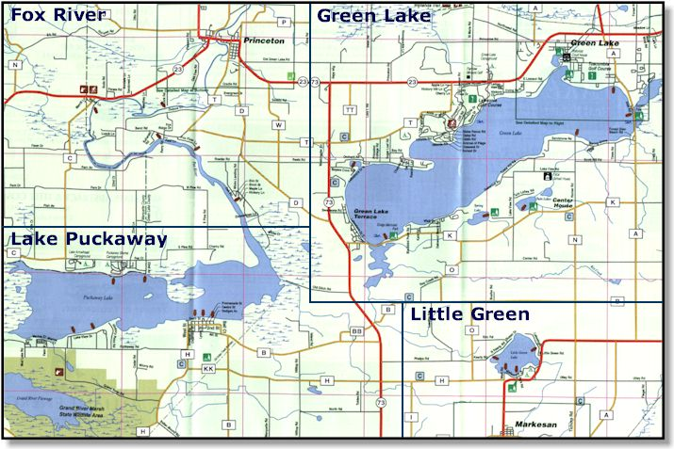
N3152 Oak Rd

